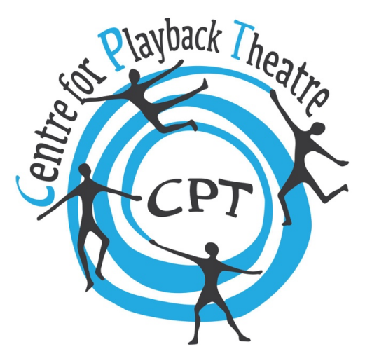
Greetings! We invite you to consider hosting the PT Leadership class in 2025.

Because Leadership in 2024 is in Asia, we hope to hold this two-week training in a European country, but we are open to other suggestions as well. Please take a look at the document Initial Information for Potential Leadership Country Hosts before you proceed.

We invite you to submit this form as an Expression of Interest. We will explore with you the possibility of this collaboration, before asking you to make a firm commitment.

Please also comment on the following questions, which are of concern to the Centre:

Who is applying? Will you be making an application as an individual or on behalf of a team? Are you applying as an Affiliated School or as a group of APTTs or as a playback theatre company?

Why your country? In a few sentences, please let us know why your country might be a good fit for the next Leadership course in 2025.

Leadership is a very international course. What restrictions are there for people to get visas to enter your country?

How many students in your country or geographical location are ready and likely to take the Leadership Course? Please review the basic requirements.

Will there be any problems making financial arrangements between the Centre and the site (i.e. transferring funds)?

What are the political or societal issues that might be a factor in running a successful Leadership course in your country?

Thank you for taking the time to respond to this. Please submit this to office@playbackcentre.org by 2024 feb 17.

We look forward to hearing from you.

Leadership Course Governance Committee (LCGC)
Centre for Playback Theatre

